**NANDHA ENGINEERING COLLEGE**

**(AutonomousInstitution)**

Erode-638 052



**TABLEAU-TWO CREDIT COURSE**

**IV–Semester**

**B.Tech-Artificial IntelligenceandDataScience**

**NAME :RAJA K C**

**BRANCH :B.TECH AI & DS**

**YEAR:II**

**TABLEAU DEFINITION AND USES**

**Tableau is a powerful data visualization and business intelligence platform that enables users to create interactive and shareable dashboards. It allows for the exploration, analysis, and presentation of data through intuitive visualizations such as charts, graphs, and maps. Tableau connects to various data sources, including spreadsheets, databases, and cloud services, to transform raw data into actionable insights.**

**Uses :**

* **Data Visualization : Create dynamic and visually appealing representations of complex datasets.**
* **Data Analysis : Perform exploratory data analysis to uncover trends, patterns, and outliers.**

**Project Title:**

**Analysis of Airbnb Listings in New York City**

**Objective:**

**The objective of this project is to analyze the Airbnb listings data for New York City to uncover trends related to prices, location popularity, availability, and customer behavior.**

**Using Tableau, the project aims to build interactive dashboards that help understand the Airbnb market and provide insights for hosts, customers, and city planners.**

# SHEET 1:

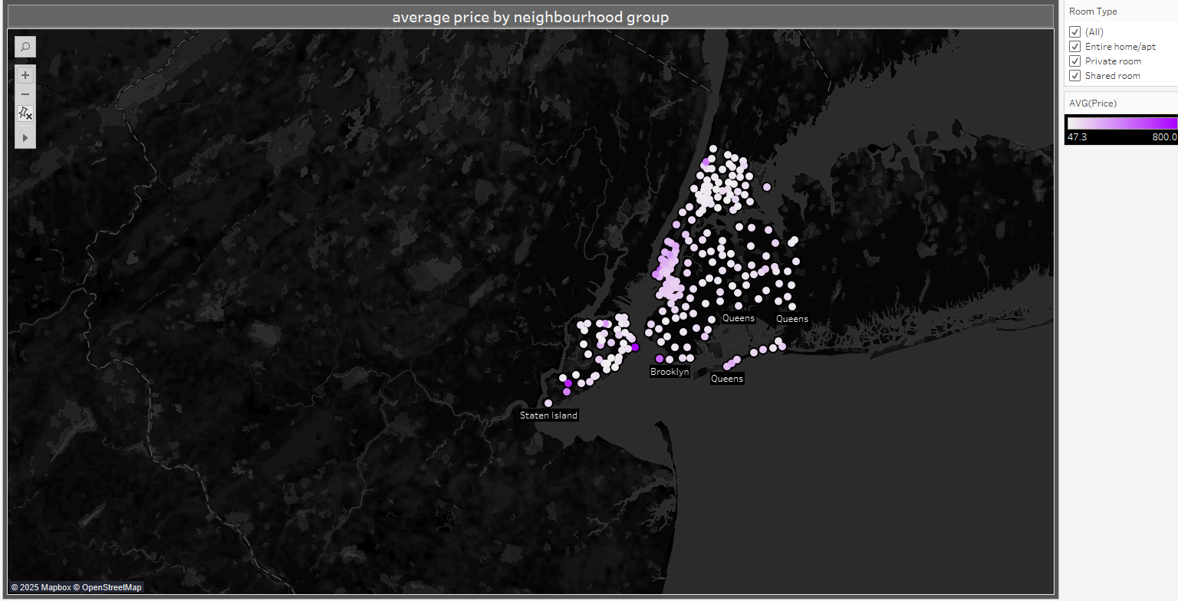

# EXPLANATION:

* This map shows the **average price** of listings across different **neighbourhood groups** in New York City.
* Brighter (more purple) dots represent areas with **higher prices**, while lighter dots show **cheaper areas**.
* Manhattan and parts of Brooklyn have **higher average prices**, while Staten Island and parts of Queens are **more affordable**.
* The right panel filters by room type and shows the price range between **$47.3 and $800**.

# SHEET 2:

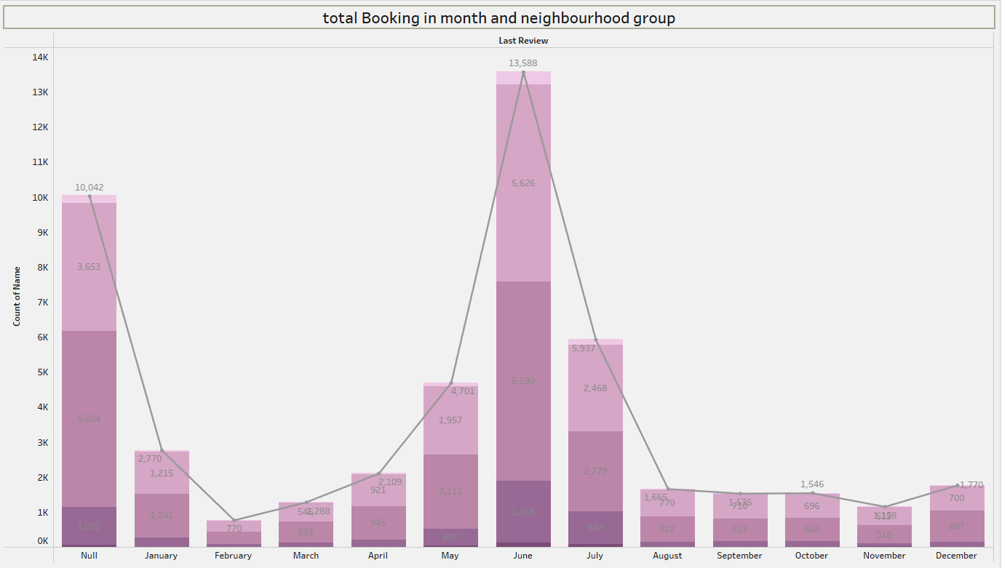

# EXPLANATION:

* This chart shows the total bookings each month across different neighbourhood groups.  
  Bookings peak sharply in the middle of the year, around summer, especially in **Brooklyn and Manhattan.**
* Early months (like January) and end months (like November, December) have lower booking numbers.
* Brooklyn and Manhattan consistently have the highest bookings compared to Bronx, Queens, and Staten Island.

# SHEET 3:

# 

# EXPLANATION:

* This image shows a donut chart titled **"total neighbourhood by neighbourhood group."**  
  It visualizes the distribution of neighborhoods across five groups: Manhattan, Brooklyn, Queens, Bronx, and Staten Island.
* Manhattan (44.30%) and Brooklyn (41.12%) make up the largest shares, while Staten Island (0.76%) has the smallest.
* The right side features a legend with different colors .

# SHEET 4:

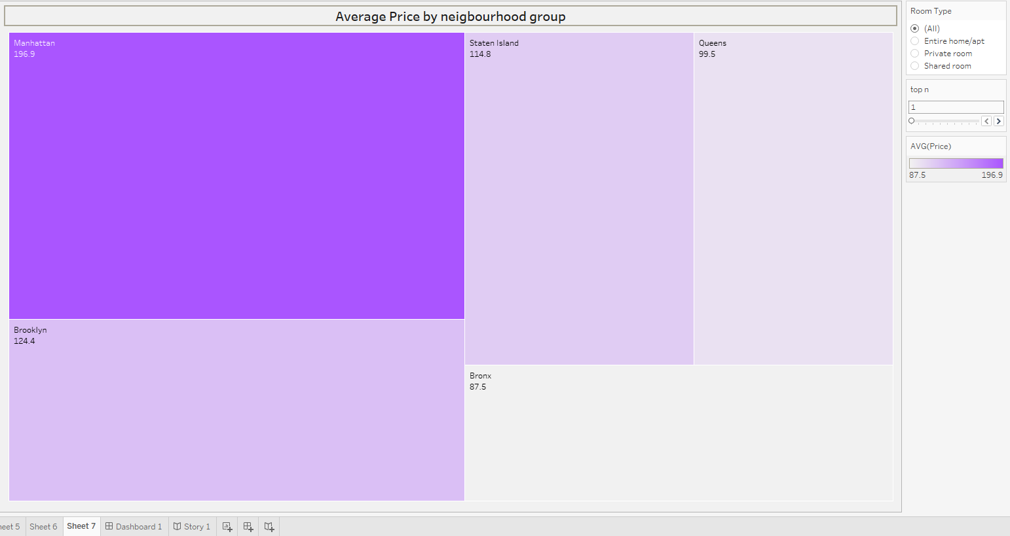

# EXPLANATION:

* **Manhattan** has the **highest average price** at **$249.2**, making it the most expensive neighbourhood group.
* **Bronx** shows the **lowest average price** at **$127.5** among all the neighbourhood groups.
* The **color intensity** (darker purple) represents **higher prices**, helping quickly spot expensive areas.
* **Brooklyn**, **Staten Island**, and **Queens** have **moderate average prices** compared to Manhattan and Bronx.

# SHEET 5:

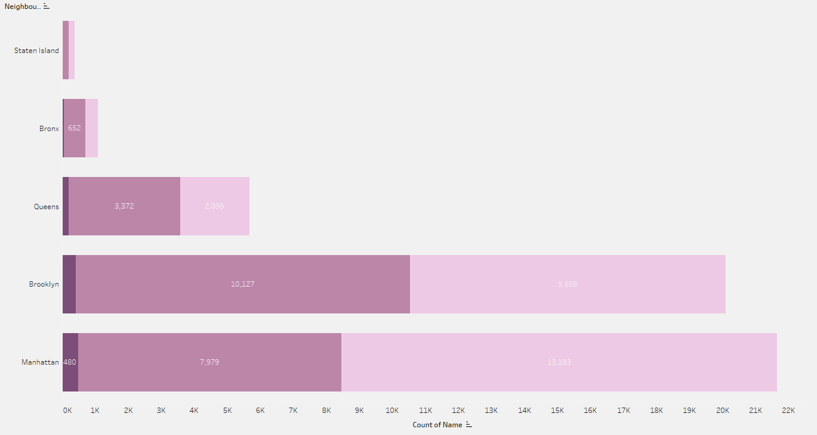

# EXPLANATION:

* This is a **stacked horizontal bar chart** showing the **count of listings** in each **neighbourhood group**.
* **Manhattan** has the **highest total number of listings** (~21,000+), followed closely by **Brooklyn** (~19,000+).
* **Queens**, **Bronx**, and **Staten Island** have **fewer listings** compared to Manhattan and Brooklyn, with Staten Island having the least.
* Each bar is **divided into segments** — these probably represent different **room types** (like Entire home/apt, Private room, etc.), though it's not directly labeled.

# SHEET 6:

# Screenshot 2025-04-27 145517.png

# EXPLANATION:

* This is a **vertical bar chart** showing the **total number of reviews** by **year**.
* There was **very little review activity** from **2011 to 2017**, with numbers growing very slowly.
* **2018** shows a **sharp increase** in reviews compared to previous years.
* **2019** saw an **explosive growth**, reaching **over 1 million reviews**, making it the most active year by far.
* The trend suggests **Airbnb's popularity** in the city **skyrocketed**

# SHEET 7:

# Screenshot 2025-04-27 150419.png

# EXPLANATION:

* This chart lists **hosts**, their **neighbourhoods**, their **average price**, and their **average number of reviews**.
* **Jj** (Harlem, Manhattan) has the **highest average number of reviews** at around **599.3 reviews**, showing high customer interaction or popularity.
* **Sonder (NYC)**, despite having **very high prices** (around $200–$286), has **extremely low review numbers** — suggesting either newer listings or low engagement.
* Hosts in **Queens** (like Angela and Maya) have **lower prices** but still attract **good review counts**, proving affordability drives bookings.

# DASHBOARD:

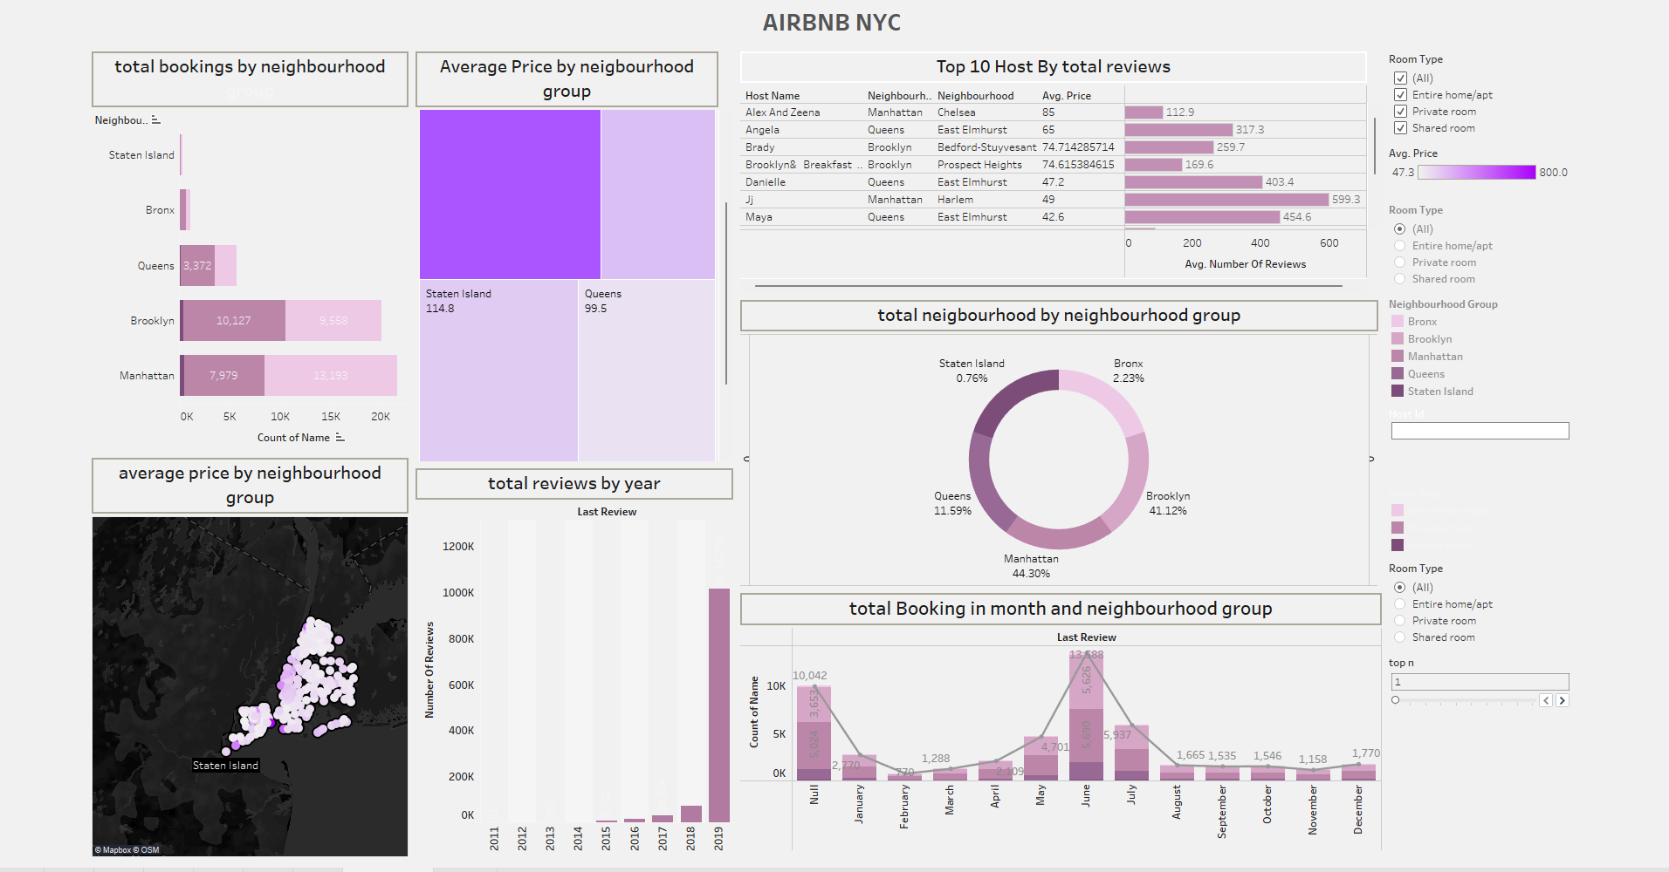

# EXPLANATION:

* **Brooklyn** leads in **total bookings**, closely followed by **Manhattan**, while **Staten Island** barely contributes (less than 1%).
* **Manhattan** has the **highest average prices** compared to other boroughs — easily visible in the color intensity of the bar and the map.
* The **Top 10 Hosts** mostly belong to **Queens**, **Brooklyn**, and **Manhattan**, and **Jj** from Harlem dominates reviews with **599.3** average reviews.
* **Review activity** exploded in **2019**, with over **1 million reviews**, indicating a major growth year for Airbnb NYC listings.

**Advanced Features Used:**

* **Filter Action:**  
  Clicking on any chart (like the Pie Chart) **filters** or **highlights** related data in other charts (like Target).
* **Change Set Action:**  
  Dynamically updates views based on **selection changes**.

**Insights:**

* Coordinators contribute the **highest net salary share** compared to other positions.
* Base salaries are fairly consistent across different roles, but **bonuses vary significantly**.
* Assistant positions are clearly filtered and highlighted when interacted, showing **targeted salary goals**.

**Key Metrics and Dimensions Used:**

* **Net Salary**
* **Base Salary**
* **Bonuses**
* **Position**
* **In/Out of Position**

**CONCLUSION:**

This Employee Data Analysis dashboard offers a **clear view** of employee salaries, ratings, and bonuses.Using **advanced Tableau actions**, it enables **interactive exploration** of key metrics.The insights help in understanding **position-wise salary distribution** and **performance trends**, supporting **better decision-making** for employee rewards and promotions.

**THANK YOU!!**